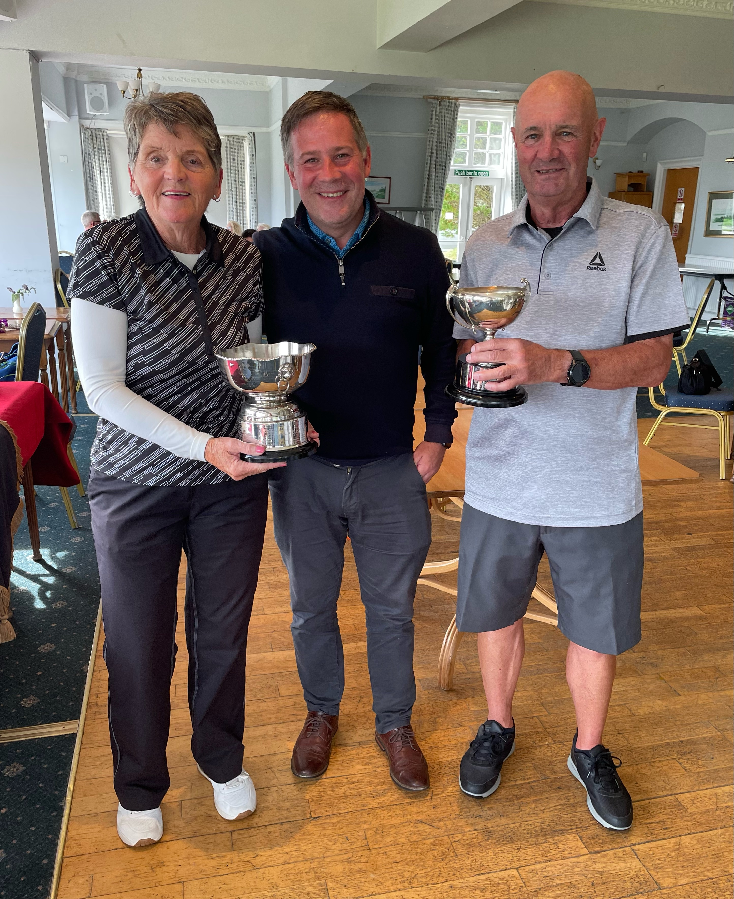

BEN BOUIE MIXED OPEN GREENSOMES

3 AUGUST 2025

PRIZE WINNERS

1st Winners of the Ben Bouie Cup & Ardmore Trophy for Best Helensburgh Pair

Rona Marshall & Graham Crowhurst £75 pp

2nd Abby & Craig Stirling £50 pp

3rd Jackie Lightfoot & Russell Makeham £35 pp

Best Front 9 Holes Dorothy & Gordon Mickel £15 pp

Best Back 9 Holes Claire & Alec Dunlop £15 pp

Nearest the Pin Ladies 9th Babs Robertson £15

Nearest the Pin Gents 11th Dougie Stewart £15

Longest Drive Ladies 17th Gillian Ping (Tulliallan GC) £15

Longest Drive Gents 18th Matthew Monaghan £15